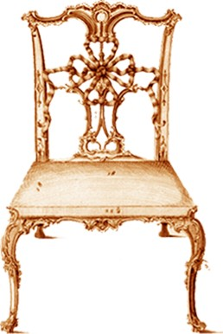
THE CHIPPENDALE SOCIETY
President: The Lord St. Oswald
Registered UK charity no. 510046

Image Reproduction Application Form: PRINT MEDIA

1. SCHEDULE OF FEES
a) Scholarly, charitable or other not for profit use No charge
b) Commercial use, print media only, worldwide £50.00 per image
c) Digital media and all other uses please contact: admin@thechippendalesociety.co.uk

2. IMAGE NUMBER, NAME OR DESCRIPTION
Image name, number or description:

Hyperlink, if available:

3. PERSONAL DETAILS
Your name:

Your organisation or role:

Date of application:

Postal address:

Email:

Phone:
4. PUBLICATION DETAILS

Is the image for publication? Yes/No

If no please describe the intended use:

Name of publication (periodical):
Please email us one pdf copy of your article for Chippendale Society records.

Name of publisher (book):

Title of article or book:

Date of publication:

Please send us a pdf of the relevant page(s) or chapter for Chippendale Society records.

5. IMAGE LICENSE AND PAYMENT
By completing and submitting this form you confirm that you have read and accept the terms and conditions of our image licence which can be found here. If payment is required an invoice will be sent to you. All images must be credited as follows: © The Chippendale Society
I hereby confirm that I have read and accept the terms of The Chippendale Society’s image rights licence. I acknowledge that I will be granted rights upon such terms to the image/s specified above, only after I have received confirmation of such from The Chippendale Society and only after payment of the licence fee as stated on The Chippendale Society’s invoice (if applicable).

Signed:

Images will follow upon acceptance of this application by The Chippendale Society and payment of the licence fee (if applicable).

